

*2022*

***27 – 30 December 2022***

***KORTRIJK (BELGIUM)***

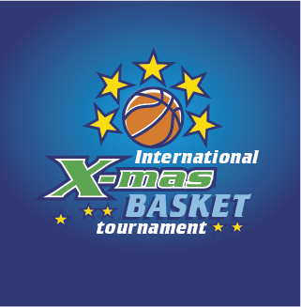

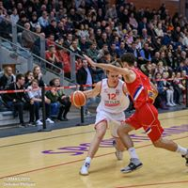





***INVITATION***

***16th International Aquarius X-Mas Tournament, in Kortrijk (Belgium)***

*Although times were difficult, we succeeded in organizing a limited version of the 2021 Aquarius   
X-Mas Tournament. We were extremely happy that 16 teams accepted our invitation and competed in MU19 and WU19. Alba Berlin (MU19) and ION Basket Waregem (WU19) were the outstanding winners.*

*In 2022, we aim at organizing a full version of our event and host all our traditional age groups and teams from all over the globe during the* ***16th Aquarius X-Mas Tournament in Kortrijk.*** *In the past years, we hosted the better teams from* ***over 30 different countries, including the United States and Canada****, and we will work hard to keep our standards from the past****,*** *focusing on offering the highest possible standards both on and off the courts.*

***For granting the highest possible competition level****, the tournament is only open for teams playing on the highest competition level in their respective countries, for basketball academies and for national and regional selections.*

***New this year:***

* ***A day will be added to the tournament, but the U19, U16 and U14 competitions will still last three days (28 to 30 December).***
* ***The MU12 (27-28 December) and WU12 (29-30 December) tournament will be spread over two days each.***
* ***MU19 and MU18 will be merged into one age group. The MU19 competition will be split into an ‘Invitational Group’ and an ‘Open Group’.***
* ***An e-basketball competition will be organized.***

***Dates:***

***December 27th, 28th, 29th and 30th 2022***

***Categories:***

* ***Men Under 19 (year of birth 2004 or later)***
* ***Women Under 19 (year of birth 2004 or later)***
* ***Women Under 16 (year of birth 2007 or later)***
* ***Men Under 16 (year of birth 2007 or later)***
* ***Men Under 14 (year of birth 2009 or later)***
* ***Women Under 14 (year of birth 2009 or later)***

Gathering Young Talent

* ***Men Under 12 (year of birth 2011 or later)***
* ***Women Under 12 (year of birth 2011 or later)***

***Number of games:***

***[](http://www.google.be/url?sa=i&rct=j&q=&esrc=s&frm=1&source=images&cd=&cad=rja&uact=8&docid=tK1-X4JU1MadYM&tbnid=pMZFg0tnMm2ZTM:&ved=0CAUQjRw&url=http://www.basketiers.nl/page/3&ei=LRdeU5iXC4iJPZmDgOgC&bvm=bv.65397613,d.ZWU&psig=AFQjCNGX48F3JF0IIHgqzLOtmX0SXbf6yw&ust=1398761619590067)FIVE games for each team.***

*[ibis Accor hotels](http://www.ibishotel.com/)****2022 Provisional tournament program***

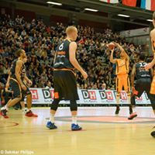***December 26th****:*

* *Start of the FIBA referee clinic.*

***December 27th****:*

* *Men U12: start of the competition.*

*(Three qualifying games for each team)*

* ***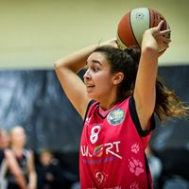****Coaches clinic in Kortrijk.*

***December 28th:***

* *Start of the U19, U16 and U14 competitions.*

*(Two qualifying games for every team)*

* *Finals of the MU12 competition*
* *Dunk contest in Kortrijk.*

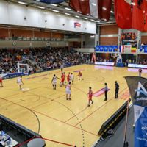

***December 29th****:*

* *Competitions U19, U16 and U14.*

*(Two qualifying games for every team)*

* *WU12: Start of the competition.*

*(three games for each team)*

* *Three-point contest in Kortrijk.*
* *Referee clinic in Kortrijk.*

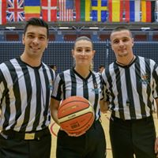***December 30th****:*

* *G-Basketball in Kortrijk*
* *Ranking games on all sites.*
* *U19, U16, U14 and WU12: Finals in Kortrijk*
* *Rewards immediately after the last game of the team*
* *MVP election after every final*

***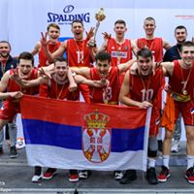*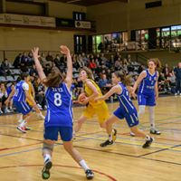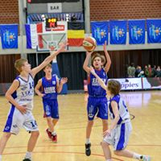**

***Information about the competitions***

* ***Game sites:*** *Kortrijk, Wevelgem, Deerlijk, Dottignies, Waregem and Zwevegem.*
* ***Number of games:***
  + ***U19, U16, U14****: every team plays two games on 28th, two games on 29th and one game on 30th.*
  + ***MU12 and WU12:*** *each team plays three games on the first day and two games on the second day of their competition.*
* ***Game length:******4 x 10’*** *for the MU19 Invitational competition,* ***4 x 8’*** *for the MU19 Open, WU19, U16 and U14 competitions,* ***4 x 6'*** *for the U12 competitions (always stopped time).*
* ***Finals:***
  + *All finals will be organized at Lange Munte (Kortrijk), the home court for several international competitions.*
  + ***Important: no timings of finals will be modified for travelling issues. So please plan the timing of your trip back in accordance.***
* ***Side events:*** 
  + ***MVP Award:*** *in every age group an MVP will be awarded. The MVP Awards are sponsored by* ***Coach Van Kers****, living legend in Basketball coaching, and by****An Wauters****, former WNBA champion and multiple European player of the year.*
  + ***Dunk contest:*** *organized in Lange Munte Kortrijk on December 28th.*
  + ***3-point contest:***  *organized in Lange Munte Kortrijk on December 29th.*
* ***Referees:*** 
  + *All games will be led by 2 or 3 official referees, under FIBA rules.*
  + *A FIBA referee clinic is organized during the tournament. The participants, part of the FIBA talent pool, will officiate the MU19 games.*
  + *All other referees are part of the FIBA, the national or regional talent pool in Belgium or the Netherlands.*
  + *International candidates can apply to be part of the tournament officials’ team, by contacting the organizer.*

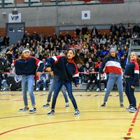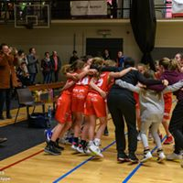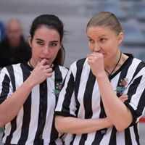

***Recent winners***

***Men U19 Invitational***

*2017: Limburg United (Belgium) runner up: Basket@Sea Oostende (Belgium)*

*2018: Basket@Sea Oostende (Belgium) Northfield Mount Hermon (USA)*

*2019: Belgrade Basketball Association (Serbia) Antwerp Giants (Belgium)*

*2021: Alba Berlin (Germany) Basketball Academy Limburg (Netherlands)*

***Women U19***

*2017: BBC Sint Katelijne Waver (Belgium) BBA Ludwigsburg (Germany)*

*2018: BBC Sint Katelijne Waver (Belgium) Israel Basketball Academy (Israel)*

*2019: Kortrijk Spurs (Belgium) ION Waregem (Belgium)*

*2021: ION Basket Waregem (Belgium) Lithuanian Regional Team (Lithuania)*

***Men U18 (new in 2019)***

*2019: Spirou Charleroi (Belgium) Den Bosch Basketball Academy (Netherlands)*

***Women U17 Invitational***

*2017: Belgrade Basketball Association (Serbia) DBC Waregem (Belgium)*

*2018: AWBB Selection (Belgium) Belgrade Basketball Association (Serbia)*

*2019: Sparta&k Moscow (Russia) Belgrade Basketball Association (Serbia)*

***Men U16***

*2017: Zaza Pachulia Academy (Georgia) Basket@Sea Oostende (Belgium)*

*2018: Israel Basketball Academy (Israel) Basketball Academy Limburg (Netherlands)*

*2019: Fikeo Team (France) Antwerp Giants (Belgium)*

***Men U14***

*2017: Fikeo Selection (France) Limburg United (Belgium)*

*2018: Woluwe United (Belgium) BC Kharkov (Ukraine)*

*2019: BS Leiden (Netherlands) Falco Gent (Belgium)*

***Women U14***

*2017: Fenerbahce Istanbul (Turkey) Notre Dame Leuven (Belgium)*

*2018: SBBK GO5 Södertalje (Sweden) Basket Namur Capitale (Belgium)*

*2019: Kortrijk Spurs (Belgium) Fikeo Team (France)*

***Men U12***

*2017: Frenchy Phenoms (France) Uccle Europe (Belgium)*

*2018: K-BT Kortrijk (Belgium) Falco Gent (Belgium)*

*2019: ION Waregem (Belgium) Selection Valais (Switzerland)*

***Women U12 (new since 2018)***

*2018: Spirou Ladies Charleroi (Belgium) Limburg Lizards (Belgium)*

*2019: Limburg Lizards (Belgium) Kortrijk Spurs (Belgium)*

***Mixed U10***

*2017: Frenchy Phenoms (France) Limburg United (Belgium)*

*2018: BBC Croonen Lommel (Belgium) Basket Wevelgem Moorsele (Belgium)*

*2019: North Limburg Basketball Academy (Belgium) Kortrijk Spurs (Belgium)*

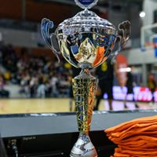

***Number of participants***

*2006: 13 teams from 3 countries*

*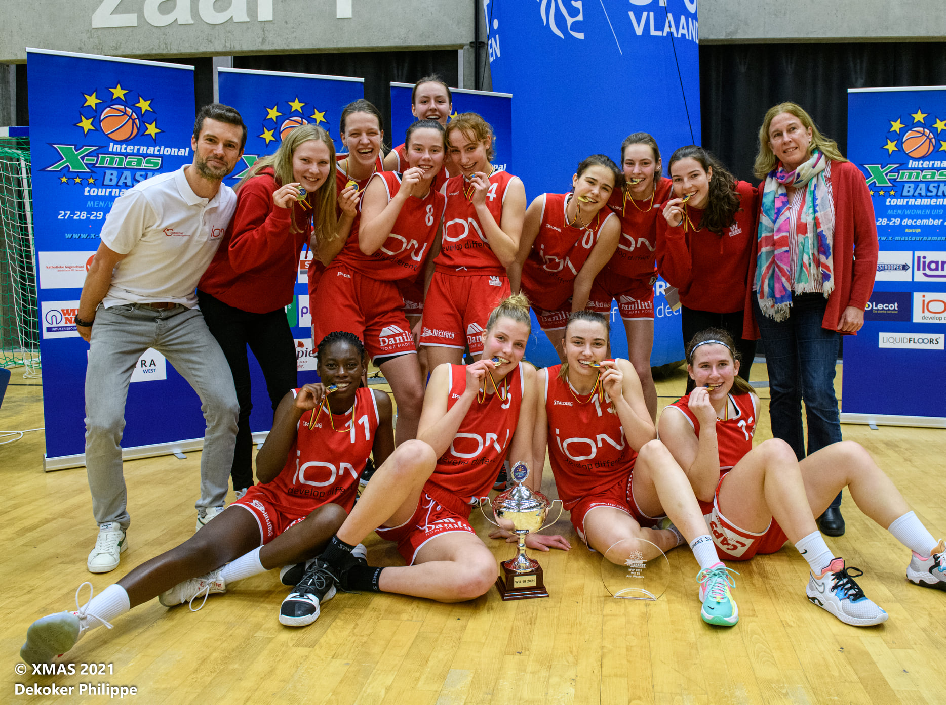2007: 16 teams from 3 countries*

*2008: 18 teams from 5 countries*

*2009: 34 teams from 9 countries*

*2010: 54 teams from 9 countries*

*2011: 68 teams from 12 countries*

*2012: 71 teams from 15 countries*

*2013: 104 teams from 16 countries*

*2014: 108 teams from 17 countries*

*2015: 125 teams from 16 countries*

*2016: 126 teams from 17 countries*

*2017: 148 teams from 17 countries*

*2018: 150 teams from 16 countries*

*2019: 172 teams from 17 countries*

*2020: not organized*

*2021: 16 teams from 6 countries (Covid-19 edition)*

***Former MVPs (in our Invitational competitions)***

***Men Women***

***2007: Lars De Lepeleire (BELGIUM) not organized***

***2008: Yannick Desiron (BELGIUM) ‘’***

***2009: David Valverdù (SPAIN) ‘’***

***2010: Ojomoh Retin (BELGIUM) ‘’***

***2011: Rokas Gustys (LITHUANIA) Lisanne De Jonge (NETHERLANDS)***

***2012: Vincent Kesteloot (BELGIUM) Manca Jelenc (SLOVENIA)***

***2013: Kanda Kanyinda (BELGIUM) Sara Sofie Mortensen (DANMARK)***

***2014: Thomas Akyazili (BELGIUM) Jeannine Guyt (NETHERLANDS)***

***2015: Koen Jorno (ISRAEL) Billy Massey (BELGIUM)***

***2016: Servaas Buyschaert (BELGIUM) Jesse Kapenga(BELGIUM)***

***2017: Leander Dedroogh (BELGIUM) Marija Filipovic (SERBIA)***

***2018: Servaas Buysschaert (BELGIUM) Amélie Brohet (BELGIUM)***

***2019: Branislav Suznjev (SERBIA) Maria Semenova (RUSSIA)***

***2021: Odin Verhoeven (NETHERLANDS) Emma Vindevoghel (BELGIUM)***

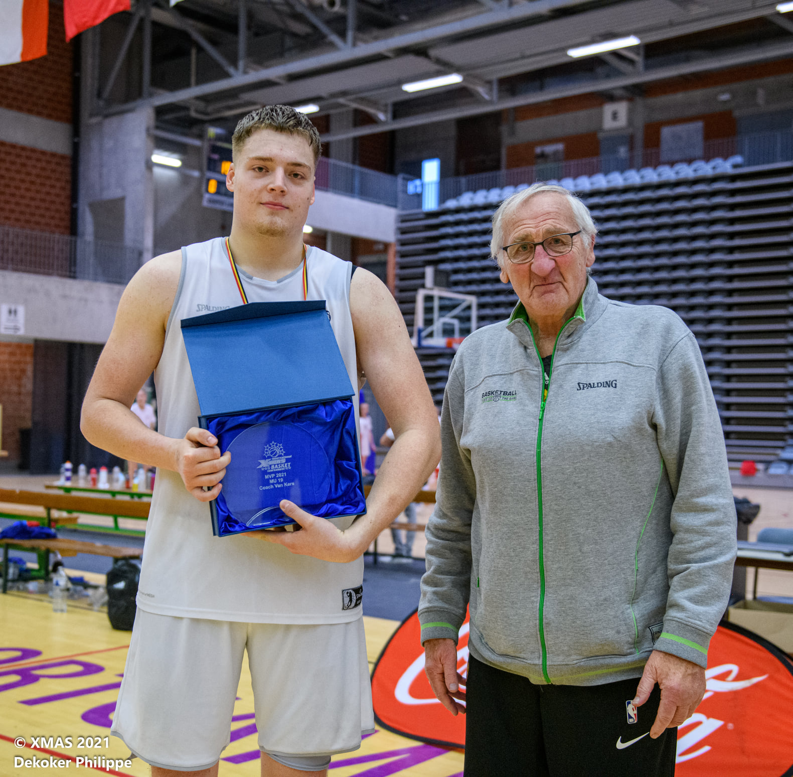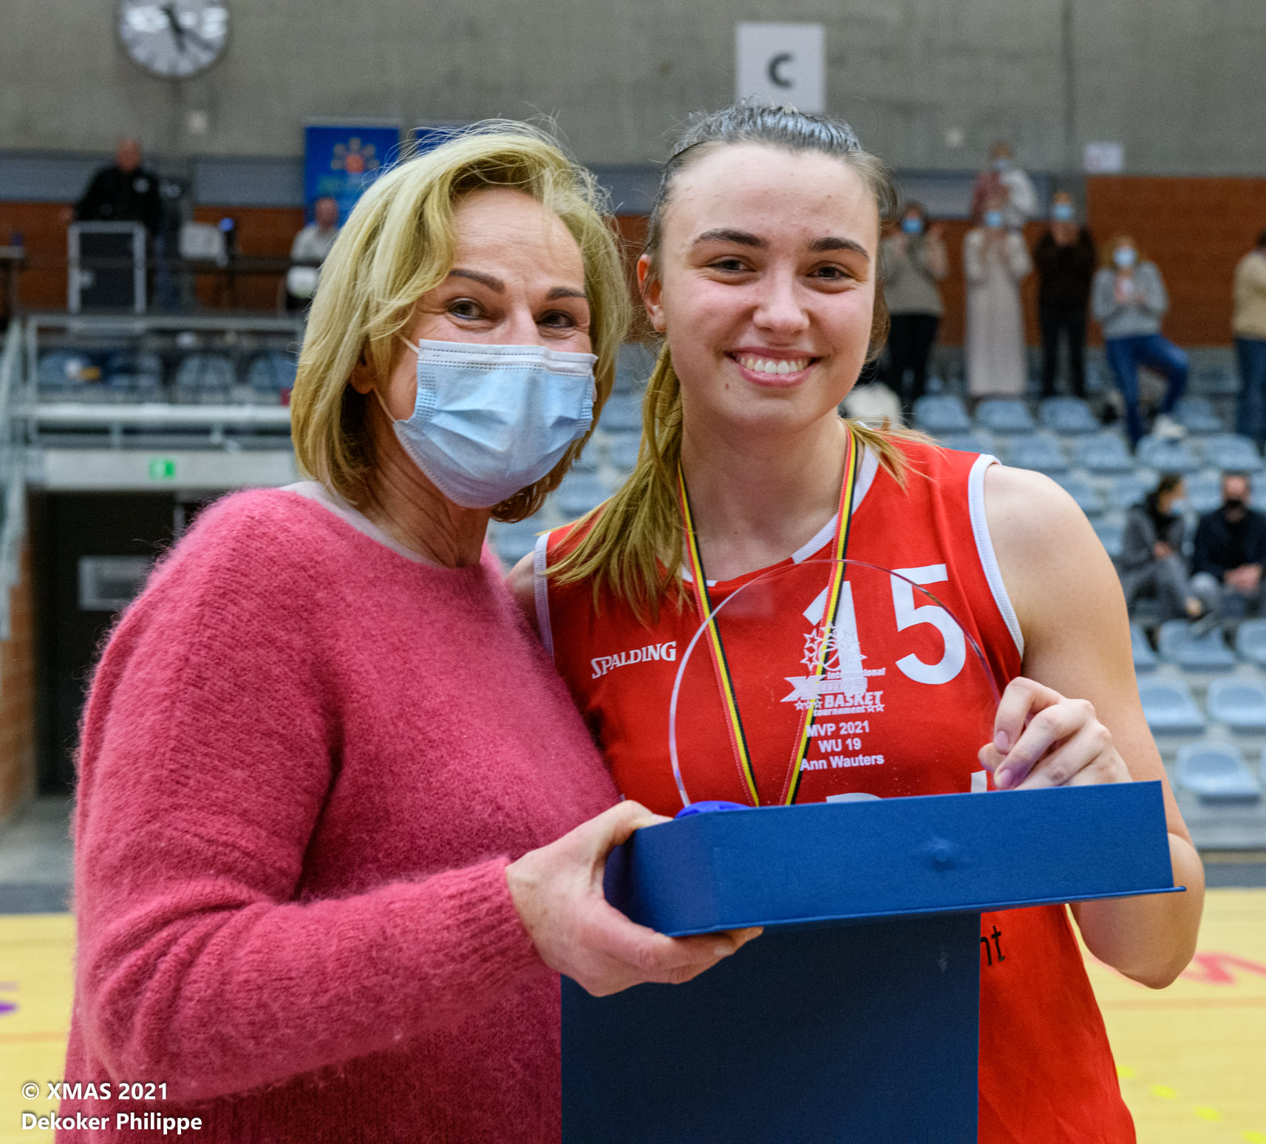

***Practical issues***

***Lodging (more details on our website)***

*Unique in youth basketball tournaments: All teams can be accommodated in very high-level hotels. The provisional list of hotels:*

* ***In Kortrijk:***

***Park hotel*** *-* ***Center hotel*** *-* ***Ibis Centrum - Ibis Styles*** *-* ***Focus Hotel*** *-* ***D-Hotel - Bootel Ahoy*** *-* ***Full House.***

* ***In the vicinity of Kortrijk:***

***Best Western Hotel Alizé*** *(Mouscron) -* ***Hotel Acacias*** *(Neuville-en Ferrain) -* ***Altia Hotel*** *(Neuville-en-Ferrain) –* ***Ibis Centre*** *(Tourcoing) –* ***Garden Hotel*** *(Bondues) –* ***Kyriad Hotel*** *(Neuville-en-Ferrain) –* ***Park Hotel*** *(Waregem)*

* ***Teams wanting to lower costs can stay in Hotel Ibis Budget in Wasquehal or Youth Hostel” Groeninghe” in Kortrijk.*** *With some lesser comfort, but still high standard !*
* *Teams are not obliged to stay in one of our hotels. Teams can also arrange their own accommodation (there are some low-cost hotels in the vicinity of Kortrijk) and take only the tournament meals (see below).*
* *Teams arriving earlier or leaving later can be accommodated additional nights in the same hotels as during the tournament at very favorable prices. The organizer can arrange this. Prices: check the financial page.*
* *An unlimited number of friends, family.... can be accommodated at the same hotels and at the same price as the team during the tournament.*

***Catering:***

* *Teams staying at hotel or hostel:*
  + *Breakfast is included in the price. A breakfast buffet is served at the hotel or hostel. Every hotel offers a high standard breakfast buffet.*
  + *The other tournament meals are served at the tournament restaurants, in or near the venues. U19, U16 and U14 teams will receive three lunches and two evening meals. U12 teams will receive two lunches and one evening meal.*
* *Teams choosing Formula C (only lunches): they will receive three (U19, U16 and U14) or two (U12) lunches at the tournament restaurants.*
* *Teams arriving on 27th can order an additional evening meal for that day. The coast of the meal will be 10€ per person.*

**Visit our website: www.x-mastournament.be**

***Transport****:*

* ***Arrival by car or by bus:*** *Kortrijk can be reached very easily, from all directions, by E17 highway.*
* ***Arrival by train:*** *Kortrijk has a main rail station with good connections to Brussels and Lille (TGV and Eurostar railway station, France).*
* ***Arrival by airplane:*** *nearby airports are Brussels National Airport (Zaventem), Brussels South (Charleroi) and Lille Lesquin. A direct train connection exists between the airports and Kortrijk railway station.*
* *We can arrange airport shuttles for teams arriving in Brussels National Airport, Brussels South (Charleroi) and Lille Lesquin for a fee of* ***200 € per trip per team****.*
* *During the tournament, all gyms can easily be reached by public transport.*
* *During the tournament, shuttle service will be organized for transporting those teams that arrived without own transport means.*

***Additional services:***

*Teams needing, for one or another reason, additional services (laundry, medical, cultural, social ...) can contact the organizer. Whenever possible we will assist you.*

***Media***

* *X-Mas TV will offer, on our website, from September on, several videos of the tournament preparations. During the tournament, clips will be updated daily.*
* *The most recent information about the tournament is available on the tournament’s web site (*[*http://www.x-mastournament.be*](http://www.x-mastournament.be)*).*
* *You can of course also follow the event, and receive all latest news through our Facebook Page (*[*https://www.facebook.com/XMastournament*](https://www.facebook.com/XMastournament)*).*
* *The situation of the registrations will be updated daily. During the tournament, the results will be adapted in real time.*
* ***New: A maximum of games on several sites will be live on Livestream !!!***

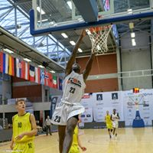

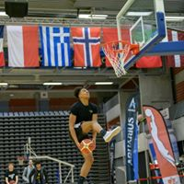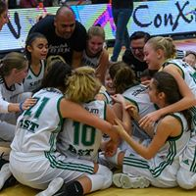

***Other activities***

* *During the Christmas period the city of Kortrijk is decorated, illuminated, ice skating is possible and Christmas markets are organized.*
* *Kortrijk is both a historical city AND a very well-known shopping city.*
* *In the vicinity of the tournament cities, you can visit other places of historical interest:*
  + *Bruges (30 minutes from Kortrijk by train)*
  + *Gent (20 minutes from Kortrijk by train)*
  + *Ypres (20 minutes from Kortrijk by train)*
  + *Lille (20 minutes from Kortrijk by train)*
  + *Brussels (1 hour from Kortrijk by train)*

*[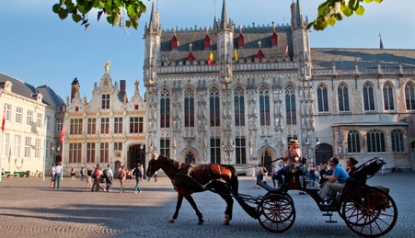](http://www.google.be/url?sa=i&rct=j&q=brugge&source=images&cd=&cad=rja&docid=8oEGp62wa6UzMM&tbnid=6KUcKIImfrkJEM:&ved=0CAUQjRw&url=http://www.hotelbrugge-oostkamp.be/&ei=VIl_Ub3rJYqa0QXZiIGwDg&bvm=bv.45645796,d.d2k&psig=AFQjCNGxUF2x-3Tpnca8I_nFw6-n4NnfvQ&ust=1367399096303691)[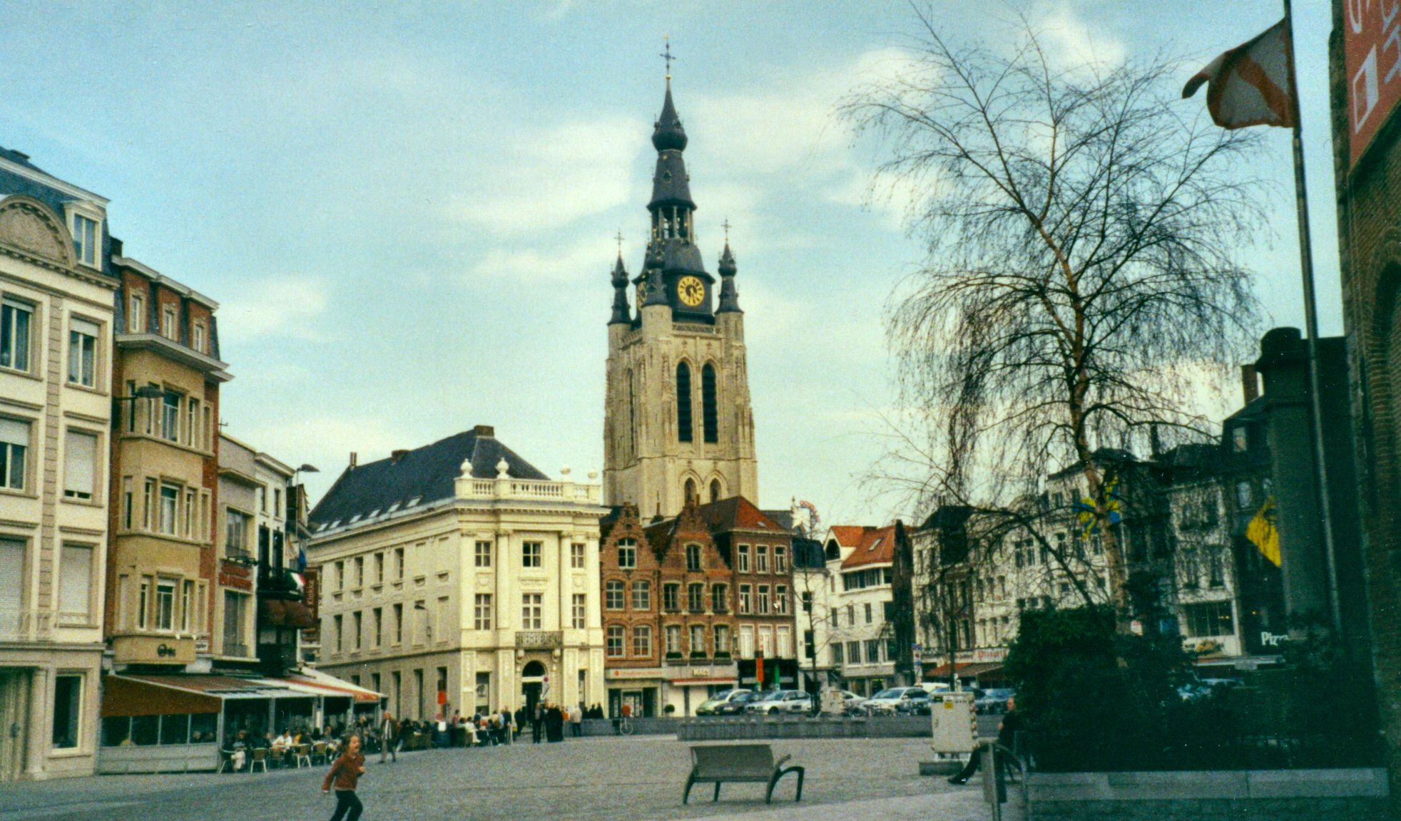](http://www.google.be/url?sa=i&rct=j&q=kortrijk&source=images&cd=&cad=rja&docid=HEQaCaBwqJ8PoM&tbnid=QTMtkVJvs9uMFM:&ved=0CAUQjRw&url=http://commons.wikimedia.org/wiki/File:Kortrijk_aka_Courtrai_in_Belgium_Redvers.jpg&ei=nYl_UZHsBOmx0QXG5YH4Ag&bvm=bv.45645796,d.d2k&psig=AFQjCNGIkNMckqChDO5MVygtgYK6xYxBvA&ust=1367399179376102)*

[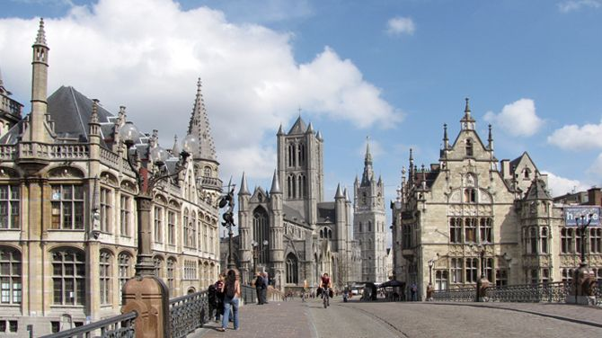](http://www.google.be/url?sa=i&rct=j&q=&esrc=s&source=images&cd=&cad=rja&uact=8&ved=0ahUKEwjhmb3TnZDMAhVFORoKHZ6XCwEQjRwIBw&url=http://deredactie.be/cm/vrtnieuws/regio/oostvlaanderen/1.2456184&psig=AFQjCNG95SZOnd2UVKs0M7ioOnj8ujzyjA&ust=1460795530755005)***[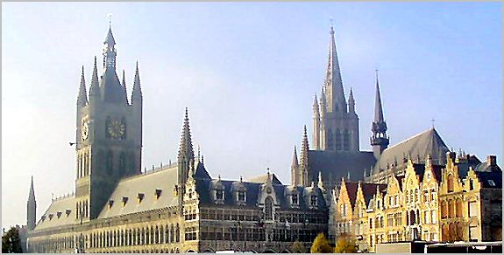](http://www.google.be/url?sa=i&rct=j&q=ieper&source=images&cd=&cad=rja&docid=3-YrcXRY2hVb2M&tbnid=N28UgqgViPQCDM:&ved=0CAUQjRw&url=http://www.trabel.com/ieper/ieper.htm&ei=XYt_UZH2NcST0AWA8YDQAg&bvm=bv.45645796,d.d2k&psig=AFQjCNEXccbKGqwmNPkpS2mwJqrxcdJ3EA&ust=1367399637362469)[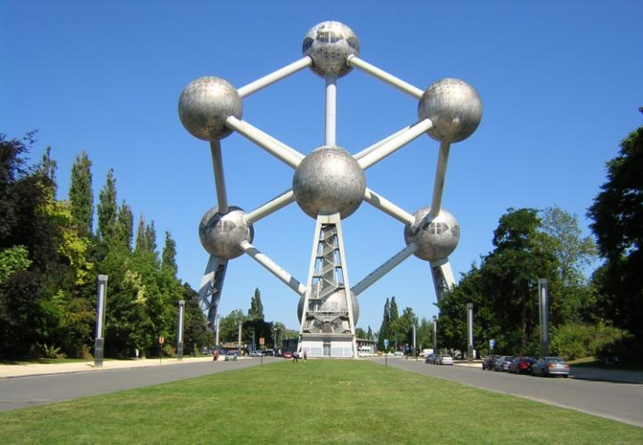](http://www.google.be/url?sa=i&rct=j&q=brussel&source=images&cd=&cad=rja&docid=yjQDP1sZj-wc_M&tbnid=nZkUDI90HMobKM:&ved=0CAUQjRw&url=http://www.gezinopvakantie.nl/2012/06/beleef-bruisend-brussel/&ei=CIt_UZT4DMGg0QWx54D4Dg&bvm=bv.45645796,d.d2k&psig=AFQjCNHV4wOm-VHVHq62M_7_2sicLbaCGQ&ust=1367399526627063)[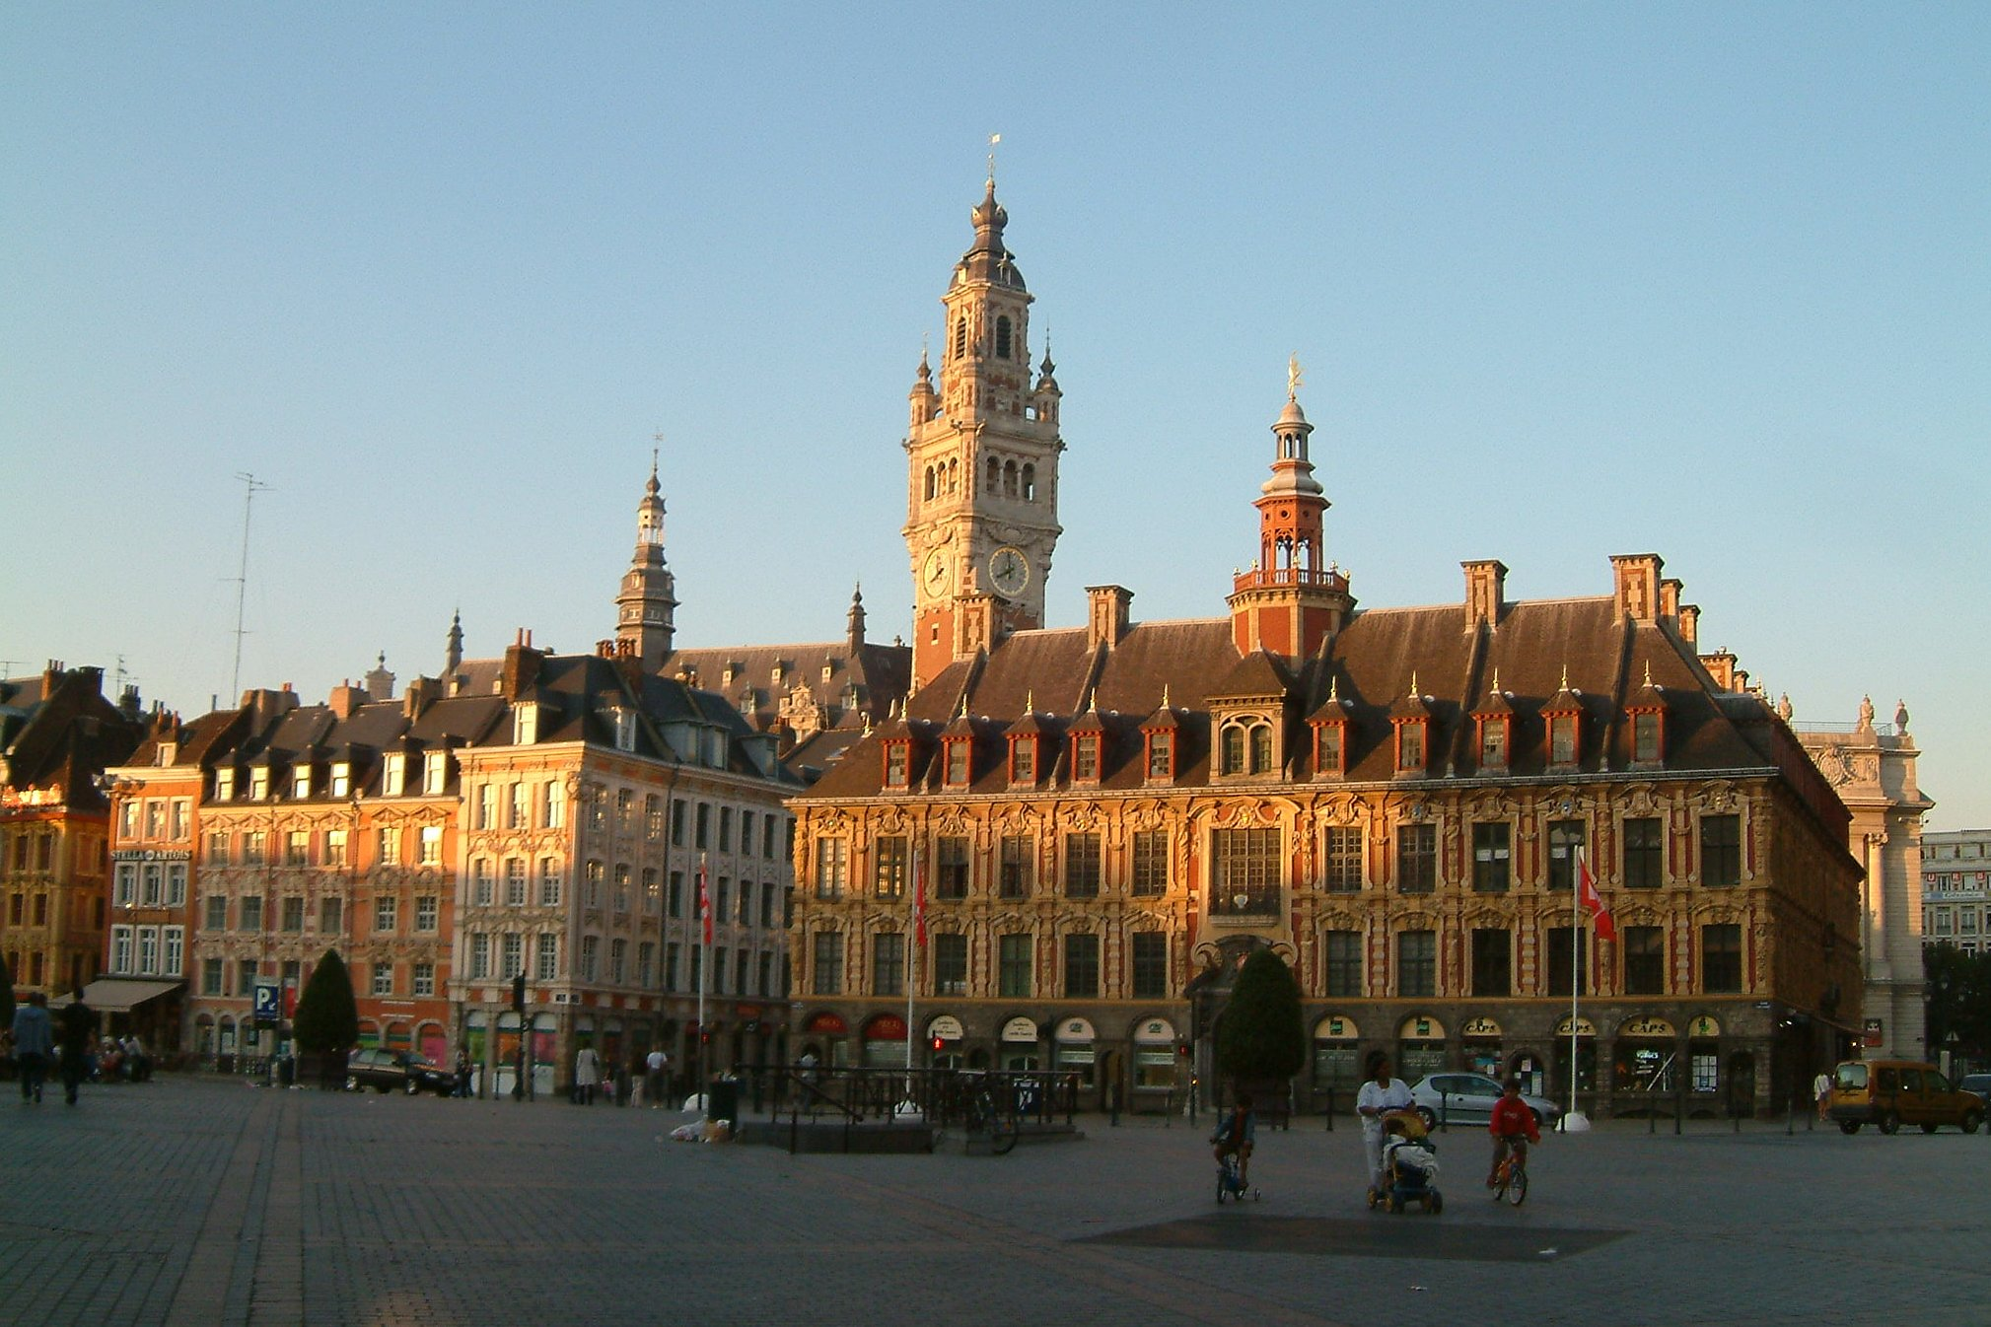](http://www.google.be/url?sa=i&rct=j&q=lille&source=images&cd=&cad=rja&docid=OZ3gHV7bYIDm2M&tbnid=FlIfaL7v50tRnM:&ved=0CAUQjRw&url=http://www.hifrance.org/auberge-de-jeunesse/lille.html&ei=4Yl_UbTzFejP0AW7-oDACg&bvm=bv.45645796,d.d2k&psig=AFQjCNFFiGzm5Aix_UtCSDno9chfx2H--A&ust=1367399255148804)[](http://www.google.be/url?sa=i&rct=j&q=ieper&source=images&cd=&cad=rja&docid=3-YrcXRY2hVb2M&tbnid=N28UgqgViPQCDM:&ved=0CAUQjRw&url=http://www.trabel.com/ieper/ieper.htm&ei=XYt_UZH2NcST0AWA8YDQAg&bvm=bv.45645796,d.d2k&psig=AFQjCNEXccbKGqwmNPkpS2mwJqrxcdJ3EA&ust=1367399637362469)***

Gent

Ypres

Brussels

Lille

Bruges

Kortrijk

***Participation costs for three days competitions   
(U19, U16 and U14)***

*There is* ***no participation fee*** *for teams in Formula A and B.*

*Four participation formulas are possible:*

1. ***Formula A (two nights at the hotel – full board)***

*This formula consists of:*

* *2 nights (28th and 29th) in one of our hotels, in double or triple room.*
* *Breakfast buffet in the hotel on 29th and 30th.*
* *3 lunches at the tournament restaurant: 28th, 28th and 30th noon.*
* *2 suppers at the tournament restaurant: 28th and 29th evening.*

***Price per person: 130€ (single room: 180€)***

***Option: Each additional night: 45€ (single room: 80€)***

**IMPORTANT INFORMATION:** THIS FORMULA IS ALSO AVAILABLE FOR PARENTS AND FAMILIES. HOWEVER, DUE TO THE STRONG RAISE OF PRICES FOR HOTELS AND FOOD, FOR THESE PEOPLE ONLY THE BREAKFASTS ARE INCLUDED IN THE PRICE. FOR PLAYERS AND COACHING STAFF, ALL THE MEALS ARE INCLUDED.

1. ***Formula B (two nights at the hostel – full board)***

*The formula is the same as formula A, but with a stay in the youth hostel Groeninghe in Kortrijk or in Ibis Budget Wasquehal. Only a limited number of rooms are available! The prices are:*

***Price per person: 100€ (single room: 130€, if available)***

***Option: Each additional night: 35€ (single room: 60€, if available)***

**IMPORTANT INFORMATION:** THIS FORMULA IS ALSO AVAILABLE FOR PARENTS AND FAMILIES. HOWEVER, DUE TO THE STRONG RAISE OF PRICES FOR HOTELS AND FOOD, FOR THESE PEOPLE ONLY THE BREAKFASTS ARE INCLUDED IN THE PRICE. FOR PLAYERS AND COACHING STAFF, ALL THE MEALS ARE INCLUDED.

1. ***Formula C (only lunches)***

*This formula consists of 3 lunches at the tournament restaurant: 28th, 29th and 30th for 14 people.*

***Price per team: 400€ (cost of the meals + participation fee)***

1. ***Formula D (no hotel or lunches)***

***Price per team:*** ***150€ (participation fee)***

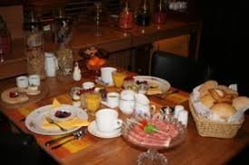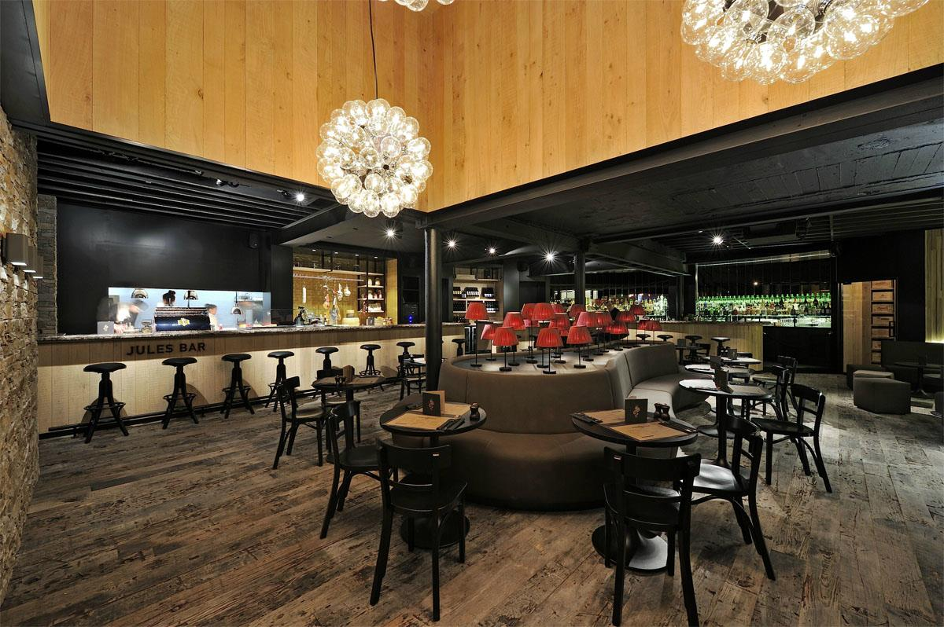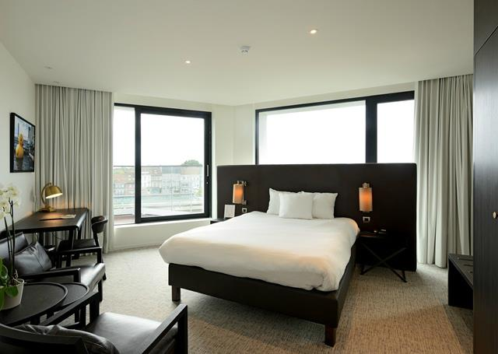

***Participation costs for two days competitions   
(U12)***

*There is* ***no participation fee*** *for teams in Formula E and F.*

*Four participation formulas are possible:*

1. ***Formula E (one night at the hotel – full board)***

*This formula consists of:*

* *1 night in one of our hotels, in double or triple room (27th for MU12, 29th for WU12).*
* *Breakfast buffet in the hotel on the day of the stay. (28th for MU12, 30th for WU12)*
* *2 lunches at the tournament restaurant: (27th and 28th for MU12, 29th and 30th for WU12)*
* *1 supper at the tournament restaurant: (27th for MU12, 29th for WU12)*

***Price per person: 75€ (single room: 95€)***

***Option: Each additional night: 50€ (single room: 80€)***

**IMPORTANT INFORMATION:** THIS FORMULA IS ALSO AVAILABLE FOR PARENTS AND FAMILIES. HOWEVER, DUE TO THE STRONG RAISE OF PRICES FOR HOTELS AND FOOD, FOR THESE PEOPLE ONLY THE BREAKFASTS ARE INCLUDED IN THE PRICE. FOR PLAYERS AND COACHING STAFF, ALL THE MEALS ARE INCLUDED.

1. ***Formula F (one night at the hostel – full board)***

*The formula is the same as formula E, but with a stay in the youth hostel Groeninghe in Kortrijk or in Ibis Budget Wasquehal. Only a limited number of rooms are available! The prices are:*

***Price per person: 55€ (single room: 75€, if available)***

***Option: Each additional night: 35€ (single room: 60€, if available)***

**IMPORTANT INFORMATION:** THIS FORMULA IS ALSO AVAILABLE FOR PARENTS AND FAMILIES. HOWEVER, DUE TO THE STRONG RAISE OF PRICES FOR HOTELS AND FOOD, FOR THESE PEOPLE ONLY THE BREAKFASTS ARE INCLUDED IN THE PRICE. FOR PLAYERS AND COACHING STAFF, ALL THE MEALS ARE INCLUDED.

1. ***Formula G (only lunches)***

*This formula consists of 2 lunches at the tournament restaurant for 14 people on the days of the tournament.*

***Price per team: 250€ (cost of the meals + participation fee)***

1. ***Formula H (no hotel or lunches)***

***Price per team:*** ***100€ (participation fee)***

***Registration***

***First step:***

*Teams can register by forwarding the registration form or by simple mail   
to* [*peter@x-mastournament.be*](mailto:peter@x-mastournament.be)

***Second step:***

*The registration is only final after payment of a guarantee of* ***250€*** *on the following account:*

*ACCOUNT NAME: BB PROJECTS*

*IBAN: BE07 6301 3050 4566*

*BIC: BBRUBEBB*

*ADDRESS: BASKETBALL PROJECTS, Kloosterstraat 2/23, B-8510 MARKE.*

***Point of contact for all information****:*

***Name:*** *Peter De Lepeleire*

***Tel****: +41 (0)27/565.40.46*

***Mobile****: +41 (0)76/347.57.47*

***Mail****:* [*peter@x-mastournament.be*](mailto:peter@x-mastournament.be)

***Skype:*** *peter_de_lepeleire*

***I am on WhatsApp***

***